Alcohol Ink Workshop – Following the Ink at the Tifton Museum of Arts and Heritage
Workshop Facilitator: Donna Falcone, dzfalcone@gmail.com and www.donnazfalcone.com

TODAY WE WILL | YOU WILL NEED | WHAT DID YOU NOTICE?
Learn about the basic properties of Alcohol Ink | Alcohol Inks
Use and observe the ink on a variety of substrates, and compare it movement | Alcohol Inks PLUS  A variety of SUBSTRATES: paper, glass, ceramic tile, YUPO synthetic paper
Create three pieces of Alcohol Ink Art to take home | Alcohol Inks PLUS  A variety of SUBSTRATES PLUS….?
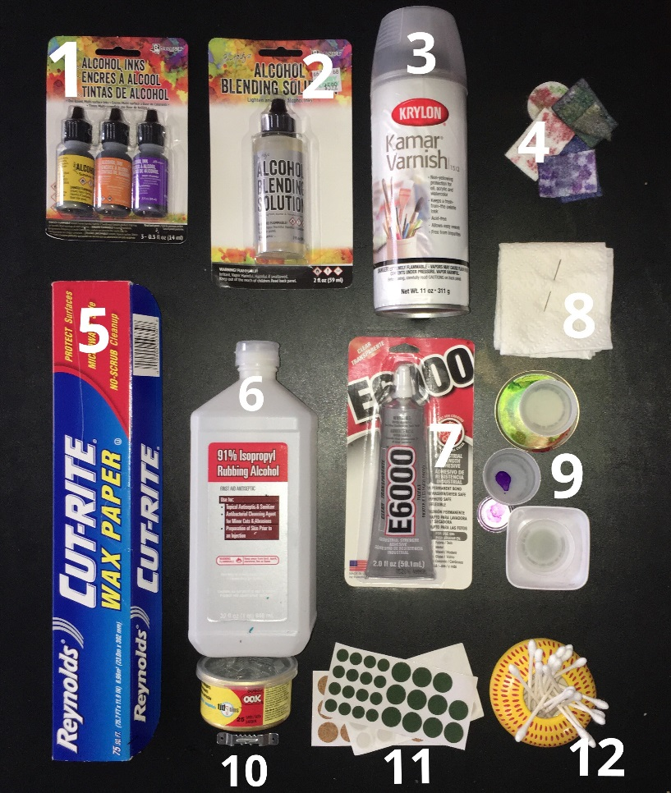
TOP 12 TOOLS FOR GETTING STARTED:
- Alcohol Ink
- Blending Solution
- KAMAR Varnish by Krylon
- Applicator Pad by Tim Holtz
- Waxed or Parchment Paper
- 91% Rubbing Alcohol
- E6000 Adhesive
- Sewing Needle
- Small dishes / plastic lids
- Sawtooth Photo Hangers
- Bumpers
- Cotton Swabs
SUBSTRATES: Alcohol Inks work best on non-porous substrates: Ceramic Tile, Glass, Synthetic Paper, Metal, Plastic.
Almost everything here is available at Walmart or other department stores. Alcohol Ink Supplies are available on site at Hobby Lobby (Tifton and Valdosta), and Michaels (Valdosta). Online at Michaels, Joann Fabric & Craft, Simon Says Stamp, Dick Blick, Amazon.com, and more. Read the fine print – make sure you are getting ALCOHOL INK… a lot of the bottles look similar.
SAFETY: Avoid using inks in tight spaces with low ventilation. It’s alcohol. It’s stinky and some people are sensitive to the odor.Know your body and your limits. If you are sensitive to odors, use outdoors or wear a mask that suits your needs. Case in point – I am not irritated at all, but my mother could only use inks outdoors. My cousin opens a window to work.If your skin is sensitive, or you prefer your own natural skin tones , wear rubber gloves. It will wash off – eventually.
TOXICITY. The inks are not foodsafe. They are not approved for use with children. Do not use on substrates that chemically react without consulting manufacturer safety guidelines (ie: photo paper).

To start with:
- Choose a substrate. Clean away dust or residue. Synthetic paper should only require a gentle wiping. Tile, metal, and other hard surfaces should be cleaned with rubbing alcohol and allowed to dry in the air.
- Select your colors! Keep it simple in the beginning. You can get a beautiful effect with just 2 to 4 colors. Remember, in the beginning you are learning what the inks do when they meet up on the surface, and you are learning what you can do with them.
- Select your application approach. There are many! Today we will work with three:
  - Dripping
  - Tip and flow
  - Dabbing with applicator
- Play! Observe! Play some more!
- Take note of what the inks do –
  - What happens when you put color one ink on another?
  - What happens when you blow on it?
  - How else can you move the ink?
  - Can you lift off unwanted marks?
  - What happens when you add a wet ink to a dry ink?
  - What happens when you add alcohol to your piece?
  - What happens when you add blending solution to your piece?
  - How are alcohol and blending solution alike?
  - How are alcohol and blending solution different?
What to do when you’re done:
- If you don’t want to keep it, you can clean it off entirely using the rubbing alcohol and start a new piece, or you can reactivate the ink, move it around, and use that to create a background for a new design.
- If you want to preserve it, let it dry and cure (that means HARD DRY – I like to give mine a week at least before I seal).
- Seal tile/glass with Kamar Varnish – one light coat followed by 2-3 heavier (but not dripping) coats. Allow drying in between. You can add an acrylic spray coating on top of the varnish if you are looking for more shine.
  - Other sealants: I have used ICE RESIN by Tim Holtz, made to go directly onto the inked surface. I have not had good luck with any other sealants as the chemical reaction causes the colors to change and sometimes dissolve or run. New prod
- To display:
  - Place tile/glass on easels for display, or
  - hang using sawtooth hook adhered with E6000 or other adhesive that works on tile and metal
  - Synthetic YUPO paper does not need to be sealed – allow to cure and then frame
  - Avoid placing in prolonged sunlight. Lightly dust surface as needed. The heaviness of your sealing process will influence the durability and lightfastness. Varnish can yellow over time.
Resources. There are many…. Here are my favorites:
- Alcohol Ink Artists: Resurrected! is a great Facebook group for beginners and advanced inkers. I highly recommend it. Make sure you read their rules for sharing. Have fun! Ask question. Share results… the ones you like and the ones you don’t! It’s a very supportive community with a terrific FILES section on topics from sealing coasters to using resin. https://www.facebook.com/groups/alcoholinkartists/
- Kellie Chasse: YouTube Channel – she has great free tutorials on YouTube and offers tuition based classes online. https://www.youtube.com/user/kellielynnart
- BOOK: Pigments of Your Imagination, by Cathy Taylor – this book is filled with strategies and techniques to take your inking further! It is available on Amazon.com
- The Artist’s Way, by Julia Cameron and Big Magic, by Elizabeth Gilbert – these books can help you get in touch with your own inner creative self, identify what you want, and finally begin to let go of any fears about creativity that you may have been carrying around.

